Description on how to download share holding pattern from Way2Wealth:

Way2Wealth website provides share holding patterns. For example,

https://www.way2wealth.com/company-information/shareholdingpattern/jsw-steel-ltd

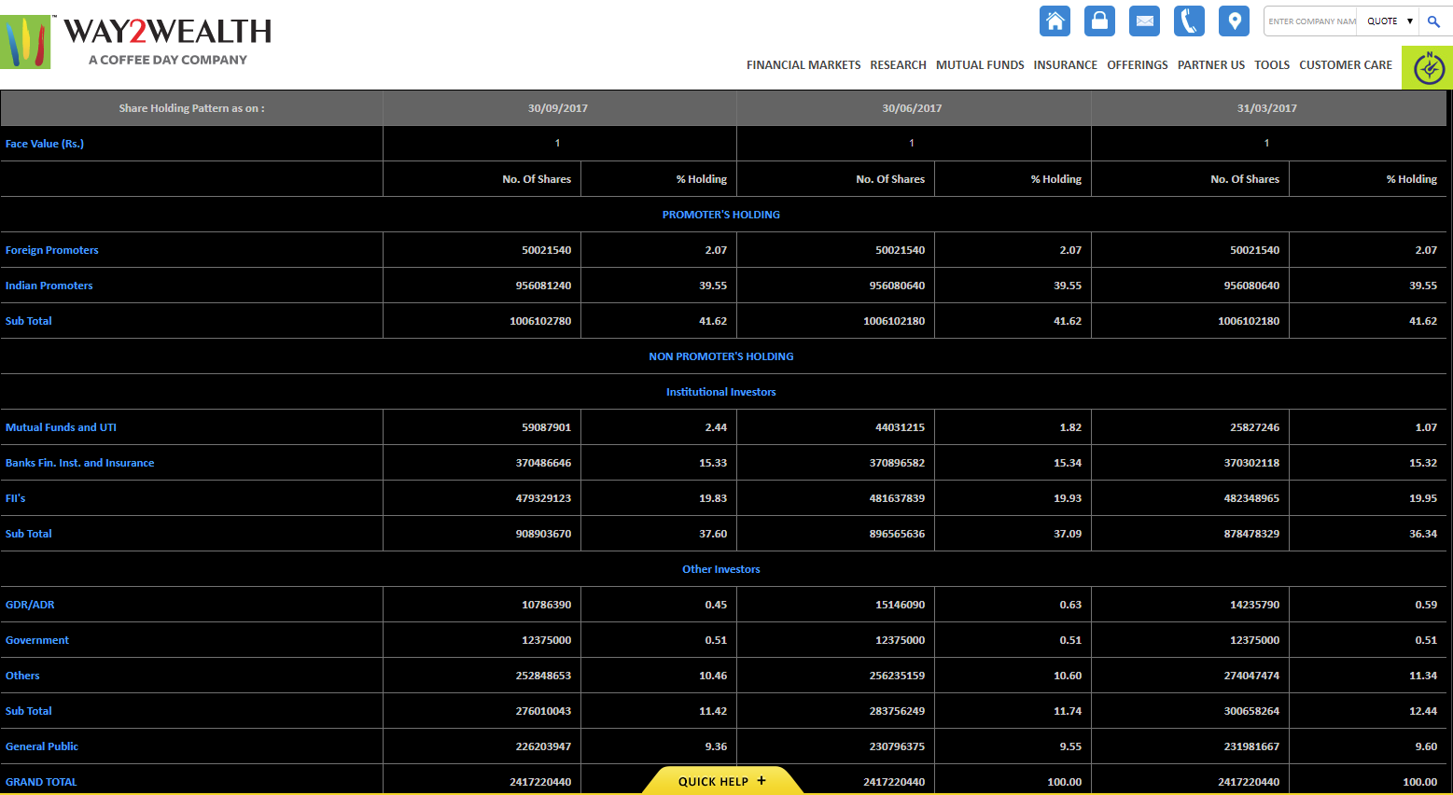
Such share holding pattern can be downloaded and saved in a spreadsheet file using MyWebServer feature in HSQuote Plus.

Set-up:

- Copy the following line and append to your existing “mywebserver.txt”, or simply substitute it the attached “mywebserver.txt”, if this line is not already there.

shareholding,https://www.way2wealth.com/company-information/shareholdingpattern/SSSS,D1,way2wealth_shareholding_D1.fmt

- Save the attached “way2wealth_shareholding_D1” file in the “fmt” subfolder in the Data File location.
- Save the attached “config_S.cfg” file in the program installation location. This file defines 1 column for Symbol only, and will be used instead of the default config.cfg file.
- Run HSQuote Plus and set up the screen as shown. Please note that the portfolio name should be “shareholding.tic”.

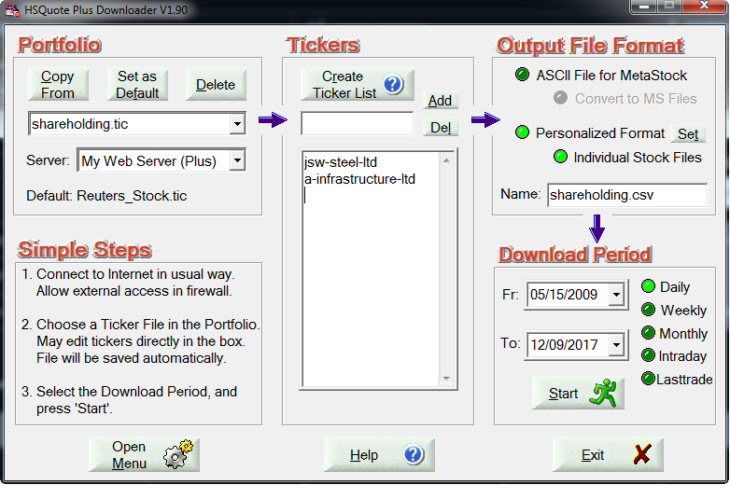

Download:

- On the main screen, select “Personalized Format”.
- Select Daily for the Download Period, and press the Start button to download data.
- Share holding pattern will be saved in the “shareholding.csv” file in the “shareholding” subfolder inside the Data File location. Individual files are stored in the “Text-Files” subfolder within the “shareholding” subfolder.

